Project: Bank Marketing (Campaign)

Week 10: Deliverables

Name: Ishwar Balasaheb Bankar
Email: ishwarb1303@gmail.com
Country: United Kingdom
Batch Code: LISUM28
Specialization: Data Science
Submission Date: 9th February 2024
Submitted to: Data Glacier
(Individual project)

Table of Contents

- Problem Description
- Business Understanding
- Data understanding (Type of data, problems and approaches to solve the problems)
- Treating outliers
- EDA

1. Problem Description

ABC Bank wants to sell it's term deposit product to customers and before launching the product they want to develop a model which help them in understanding whether a particular customer will buy their product or not (based on customer's past interaction with bank or other Financial Institution). This is an application of the organization’s marketing data.

2. Business Understanding

In predicting the results of marketing campaign for each customer and interpreting which all features affect the results, will help the organization understand how to make campaign more efficient. Moreover, in categorizing which segment of customers subscribed the term deposit, helps to identify who is more likely to buy the product in future thereby developing more targeted marketing campaigns. This can be achieved using ML model that shortlists the customer whose chance of buying the product is more so that their marketing channel (tele marketing, SMS/email marketing etc) can focus only to those customers. This will save resource and their time.

3. Data understanding

• Types of data

The dataset contains 20 independent variables and 1 dependent variable. The independent variables are the following:

- - age (numeric)
- - job : type of job (categorical: 'admin.','blue-
collar','entrepreneur','housemaid','management','retired','selfemployed','services','student','technician','unemployed','unknown')
- - marital : marital status (categorical:
'divorced','married','single','unknown'; note: 'divorced' means divorced or widowed)
- - education (categorical:
'basic.4y','basic.6y','basic.9y','high.school','illiterate','professional.cour se','university.degree','unknown')
- - default: has credit in default? (categorical: 'no','yes','unknown')
- - housing: has housing loan? (categorical: 'no','yes','unknown') 7 - loan: has personal loan? (categorical: 'no','yes','unknown') # related with the last contact of the current campaign:
- - contact: contact communication type (categorical:
'cellular','telephone')
- - month: last contact month of year (categorical: 'jan', 'feb', 'mar', ..., 'nov', 'dec')
- - day_of_week: last contact day of the week (categorical:
'mon','tue','wed','thu','fri')
- - duration: last contact duration, in seconds (numeric). Important note: this attribute highly affects the output target (e.g., if duration=0 then y='no'). Yet, the duration is not known before a call is performed. Also, after the end of the call y is obviously known. Thus, this input should only be included for benchmark purposes and should be discarded if the intention is to have a realistic predictive model. 12 - campaign: number of contacts performed during this campaign and for this client (numeric, includes last contact)
- - pdays: number of days that passed by after the client was last contacted from a previous campaign (numeric; 999 means client was not previously contacted)
- - previous: number of contacts performed before this campaign and for this client (numeric)
- - poutcome: outcome of the previous marketing campaign
(categorical: 'failure','nonexistent','success')
# social and economic context attributes
- - emp.var.rate: employment variation rate - quarterly indicator (numeric)
- - cons.price.idx: consumer price index - monthly indicator (numeric) 18 - cons.conf.idx: consumer confidence index - monthly indicator
(numeric)
19 - euribor3m: euribor 3 month rate - daily indicator (numeric) 20 - nr.employed: number of employees - quarterly indicator (numeric) Output variable (desired target):
21 - y - has the client subscribed a term deposit? (binary: 'yes','no')

The independent variables are a mix of categorical and numerical values.

As instructed in the dataset, the duration feature is dropped from the dataset.

• Problems in the data
The dataset contains a total of 41188 rows, out of which there were a total of 12 duplicate rows. The pandas drop_duplicates method is used to drop the duplicate rows.

Missing Values:
There are no missing values in the dataset.
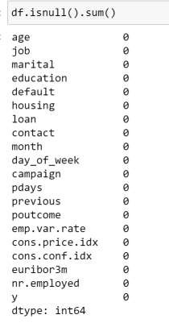
Outlier detection

Outliers are detected using box plots.
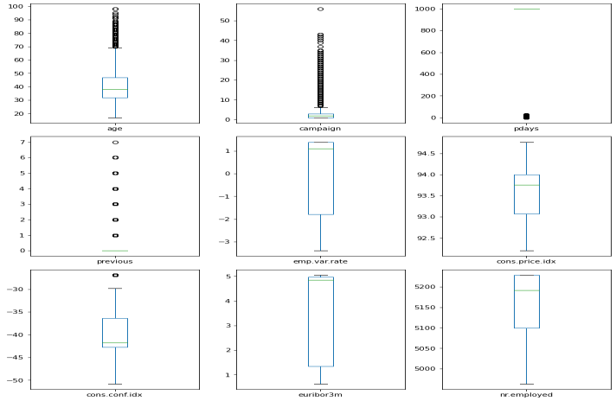
Outliers represent those values which are at an abnormal distance from the central distribution of data points. These values affect the statistics of the data mainly mean and mode. Therefore it’s important to deal with outliers in the data cleaning stage so that the performance of the model don’t get compromised.
In the box plot, outliers are seen in the features age, campaign, pdays and previous which are indicated as data points outside the whiskers of the box plot.

• Approaches to overcome the problems

Considering the statistics of the outlier features
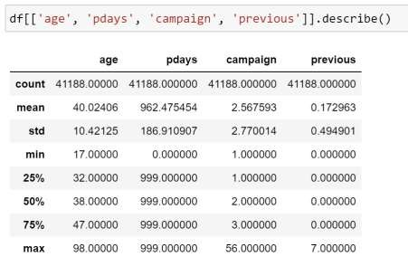

- age: The maximum value of age is 98 which seems to be realistic.
Therefore, it’s not dropped.

- pdays: number of days that passed by after the client was last contacted from a previous campaign. From the statistics, the maximum value of pdays is 999. In the features description, this value means the client was not previously contacted. Moreover around 96% of rows contains this value, therefore dropping rows containing 999 seems unrealistic.
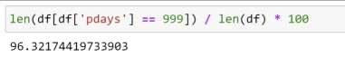

- campaign: 'campaign' holds the number of contacts performed during this campaign and for this client. From the statistics, the maximum value is given as 56 which is clearly noise. Numbers for 'campaign' above 20 is around 0.38%.
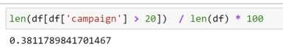
Therefore, I suggest to impute those rows with average of campaign values.

- previous: 'previous' holds the number of contacts performed before this campaign and for this client. Since the maximum value of 7 doesn’t seem to be a noise, we I chose to ignore this outlier.

4. Treating outliers
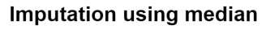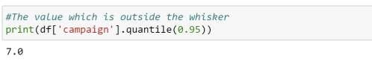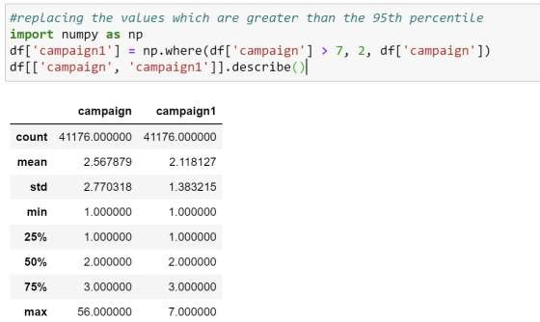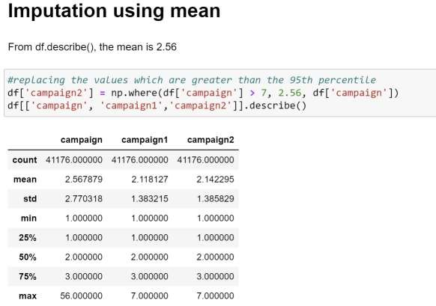

Statistics of the dataset after both median and mean imputation remains more or less the same.
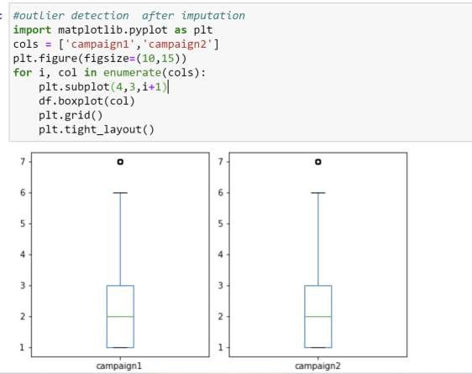

5. EDA and recommendation

- Exploring categorical values
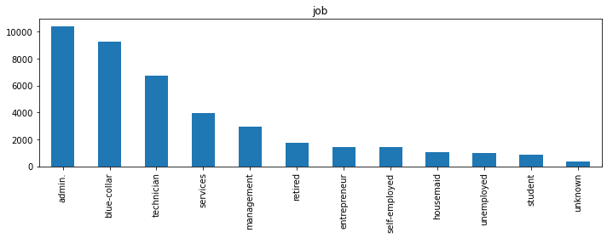
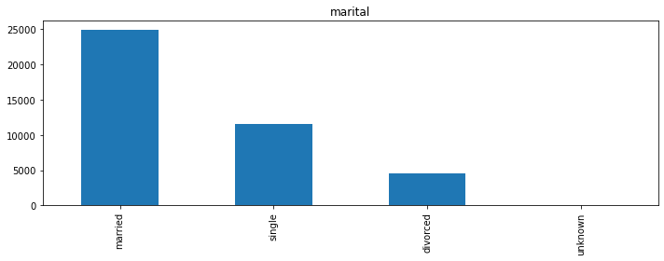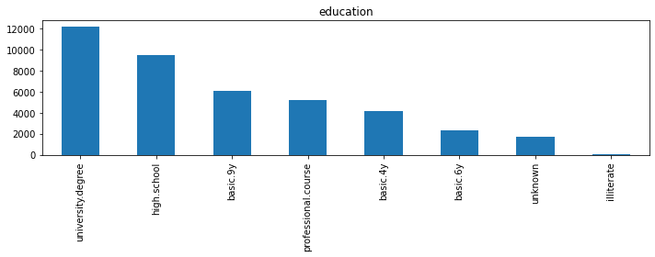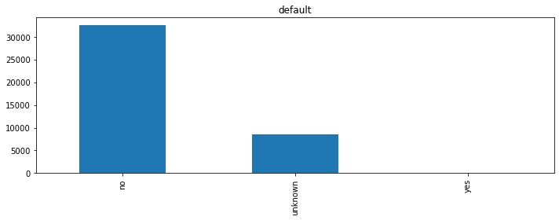
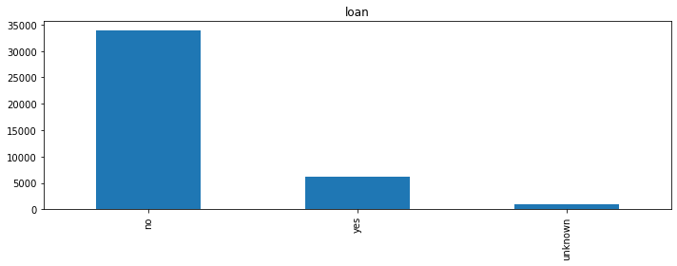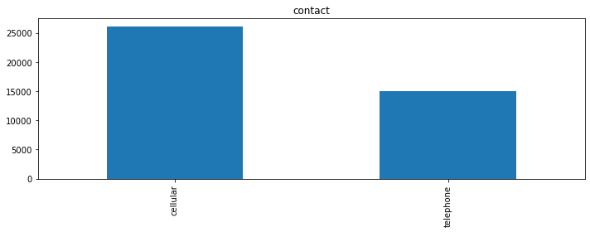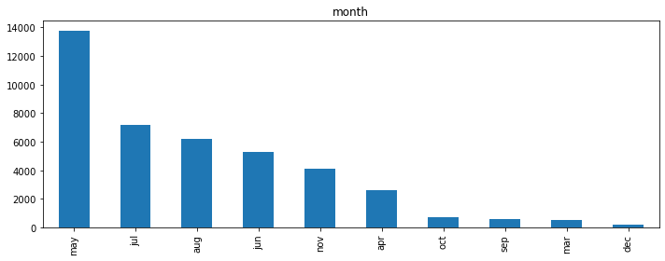
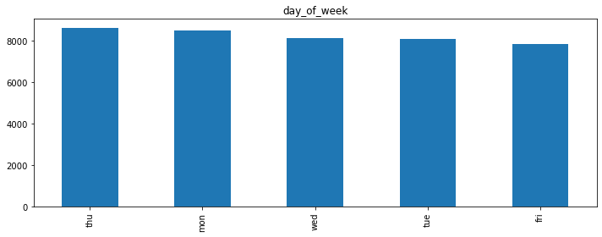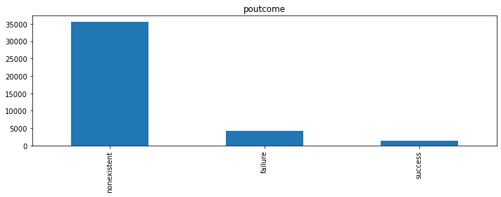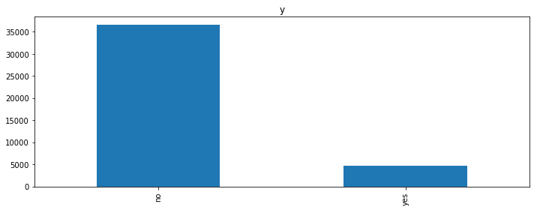

- Exploring numerical features
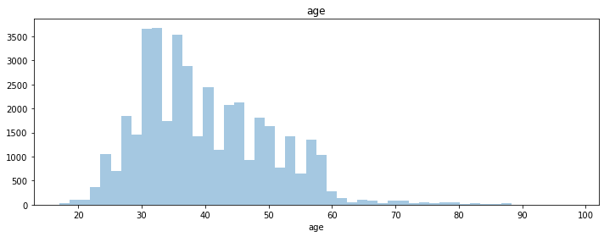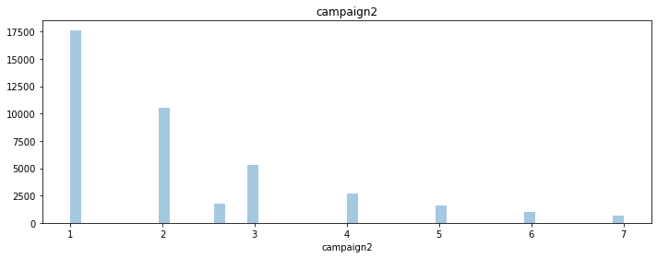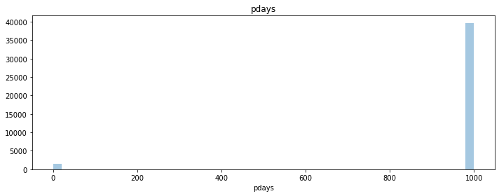
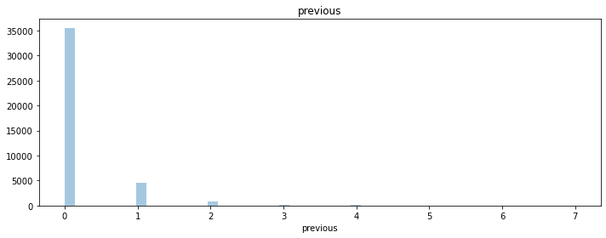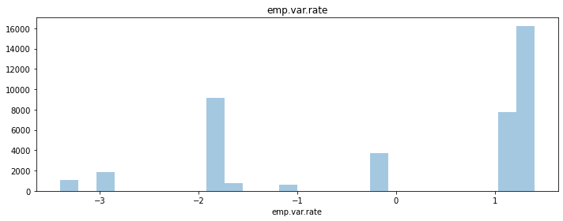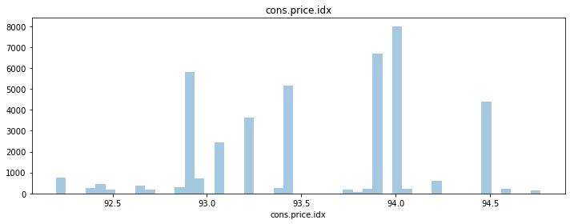
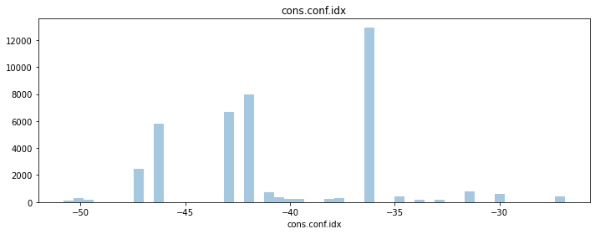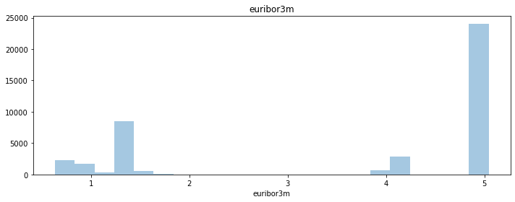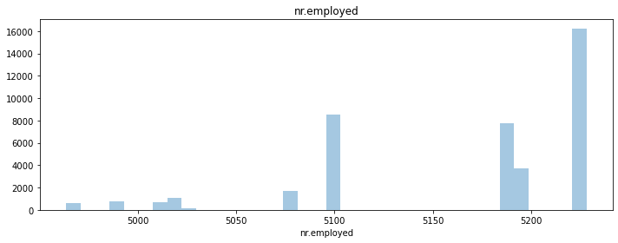

- Correlation matrix
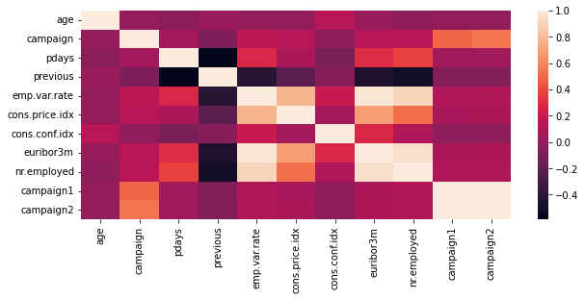

- Classification of the customer base across age-groups
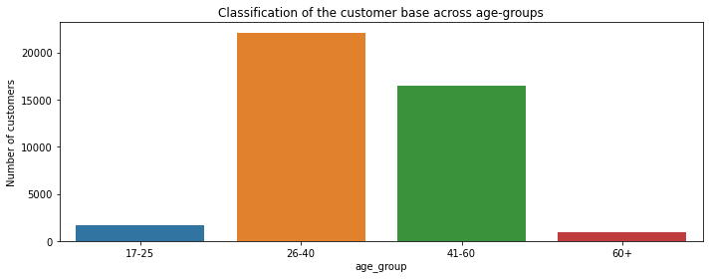

- Looking at relation between different age groups and the output label y
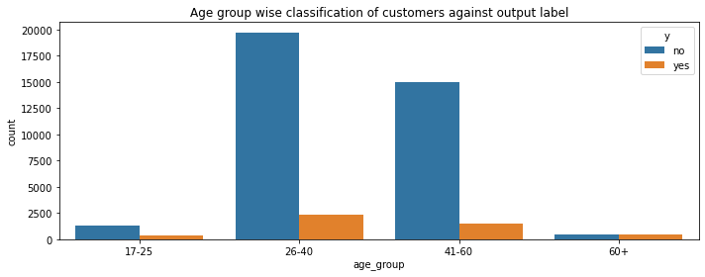
Observation: In the age-groups of 26-40 and 41-60 yrs, majority of the people are not subscribed to the term deposit plan

- Looking at relation between Number of contacts made to the customer
(campaign) and the output label y
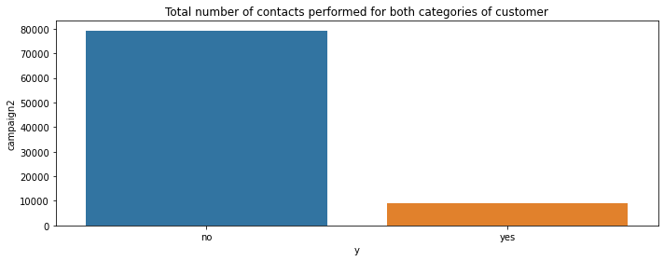
Observation: When a greater number of contacts is made to the customer, they haven't subscribed to the term deposit plan

- Looking at relation between 'age_group' and 'campaign' that is number of contacts performed for each age group
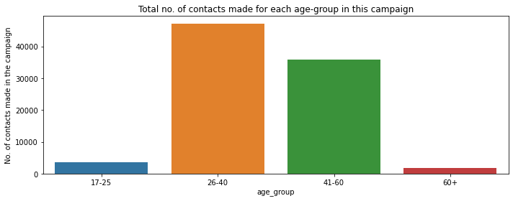

Observation: The 26-40 and 41-60 age-groups witness majority of the contacts made in this campaign. These two age-groups seem to the target groups for the bank.

- Looking at relation between job and the output label y
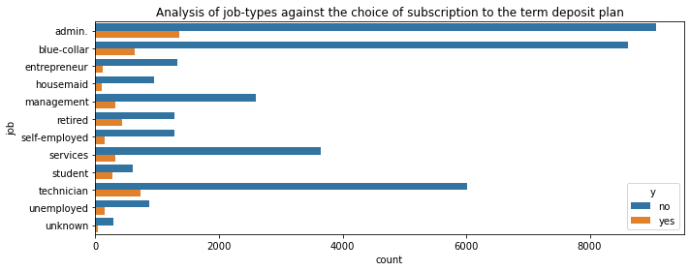
Observation: Looking at the jobs, 'admin', 'blue-collar' and 'technician' are the prominent jobs and most of the customers in these jobs have rejected the term deposit plan.

- Analysing marital status and the output label
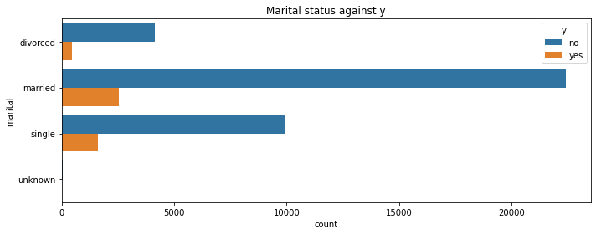
Observation: married and single customers are the majority of the customer base and comparatively married customers have taken the term deposit

- Analysing the different education levels of a customer against the choice of subscription
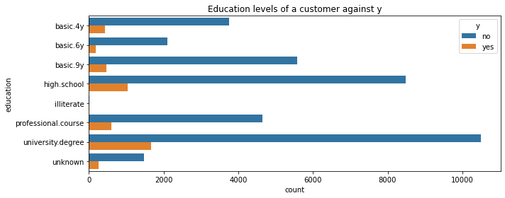
Observation: Customers with university degree have subscribed to the term deposit more

- Analysing the default status against the choice of subscription
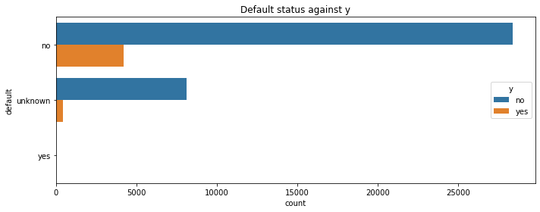
- Analysing housing status and y
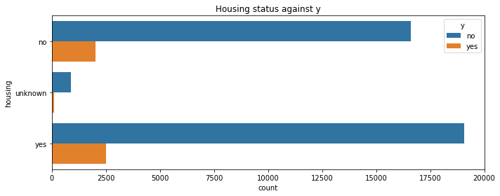

Observation: Number of customers who have subscribed to the term deposit is comparatively more for those with housing loan

- Analysing loan status and y
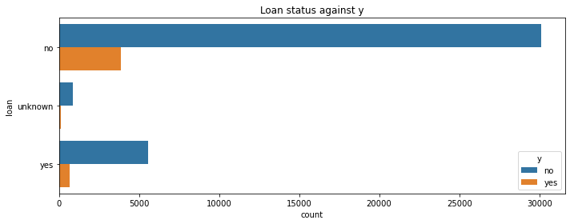
Observation: Number of customers who have subscribed to the term deposit is comparatively less for those with personal loan

- Analysing poutcome and y
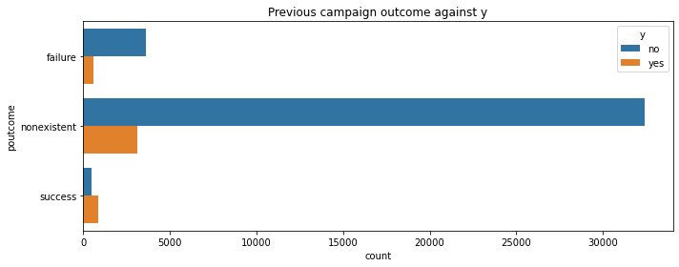
Observation: The success rate of previous marketing campaign has resulted in more number of people subscribing to the term deposit

